FLIGHT CATERING

INTRODUCTION

It is possible to dine in five-star luxury while travelling at 600 miles per hour, six miles above the surface of the earth. To the average person, now used to air travel, this may not seem remarkable. But the average person is unaware that there may be over 40,000 separate items loaded onto a Boeing 747 (popularly known as the jumbo jet). This load occupies 60 m2 and weighs six tonnes and the loading time may be less than 50 minutes. In view of this, some might say that it is not just remarkable that air travellers may dine so well; it is remarkable that they can do so at all.
Like passenger railroads and cruise lines, the first commercial airlines catered specifically to wealthier classes. These customers demanded the finest service and were willing to pay the price. En-route meals served two purposes: stay the hunger and pass the time. The airline companies also gave their thought on catering aspects. As technology advanced, so did the catering possibilities. Inflight catering presented a unique set of challenges for the cooks and crew serving the food. The first airline meals were served by Handley Page Transport on 11 October 1919.
A BRIEF HISTORY
Early commercial foodservice: The first airlines were created after World War I by former military pilots. Their purpose was mail delivery, not passenger transport. Passengers were gradually included on flights...Since passengers were considered an necessary evil by the pilots who ran ...the airlines, no thought was given to any foodservice for them, although the pilots and other members of the crew might sometimes share a box lunch sandwich or a thermos of coffee with them. It was not until 1936, with the development of the DC-3, that the first airplane galley was introduced by American Airlines. That galley was quite primitive by modern standards as there was no electrical power available for heating foods or beverages, and all hot foods and liquids were boarded at ready-to-serve temperatures and held in hot thermoses. Three years later, the Boeing 307 Stratoliner, the first aircraft with a pressurized cabin that permitted commercial flights above the weather, was developed with a galley no more advanced than that of the DC-3. Primitive though it was, the DC-3...revolutionized air travel in the United States, and it was in this plane that routine, planned passenger foodservice became the standard for the industry...Also in the 1930s, Pan American Airways developed extensive galleys on their flying boats.
By the mid-1930s, airlines were beginning to realize the importance of inflight foodservices and were becoming concerned about both the quality of the food products available and the high prices charged by the airport terminal restaurants wehre they usually bought their food supplies. United Airlines...was the first airline to recognize the marketing potential of inflight foodservice as the competition of airlines increased. United FOUND AN ANSWER TO THE PROBLEM answer to the problem--build its own flight kitchens at airports where its flights landed. The first experimental kitchen was completed in Oakland, California in December 1934. Operating its own kitchen was so successful for United...United eventually built a chain of twenty kitchens throughout the United States..
Pioneering caterers: Marriott was one of the earliest inflight caterers as a result of innovative actions by William Kahrl, the manager of a new Marriott Hot Shoppe across the road from Washington's Hoover Airport (now Washington National Airport) in the late 1930s. First aerial restaurant[1925]: The First aerial restaurant car in the world is now engaged on the regular London-Paris airway service. A uniformed steward, the first aerial waiter, is in attendance, and passengers, and passengers on the aeroplane can obtain hot and cold meals while flying thousands of feet in the air.
Around 1945, Pan American worked together with Clarence Birdseye and Maxson Company to create the convection oven, which would allow frozen foods to be heated on board the aircraft. Maxson called the first convection oven it designed the Whirlwind Oven: it had a heating element in the fort of a fan and held six meals. Soon afterward, the microwave oven was developed; it has since become the industry standard in aircraft food service preparation. The first meal trays were served on pillows on passengers' laps, until trays have been developed with lids that would serve to elevate the food in front of the passengers. Finally, foldout service trays were installed in the seat backs.
DEFINING AIRLINES CATERING
Airlines catering is defined as the highly specialized skill, technology and quality oriented food catering for the airline passengers and the crew members with a greater emphasis on hygiene aspects and just in time production. This also involves an intricate planning regarding loading and off loading, the flight time schedules, lay offs and the movement and management of trolleys.
AIRLINES CATERING IS DIFFERENT FROM RESTAURANT CATERING….
Flight kitchen production is a typical form of mass catering, but has some unique features distinct from food preparation in restaurants and hotels. The time difference between food production in the flight kitchen and finally serving it on board an aircraft with limited kitchen facilities makes flight catering a high-risk food preparation operation. The complexity of the production procedures in the flight kitchen also increases the microbiological hazards associated with this type of food preparation. Major factors affecting the hygienic quality of the food are the size of the operation, the complexity of the in-flight service, the number of airlines catered for, the number of flights serviced during the day and the duration of the flights to be serviced.
Understanding the airlines catering, some salient features can be easily identified which makes this kind of catering different from restaurant catering:
1) Hygiene is a very important factor in any kind of food production but as far as airlines catering is concerned, it assumes a much more importance to the extent the entire production schedule is designed as per the HACCP requirements.
2) Any food poisoning case can become critical as food is consumed miles above the ground where immediate medical help will not reach. Again, say, for instance, the pilot and the co – pilot gets affected by the food………who’ll fly the aircraft to safety!!!!!!! Thus, one needs to be more careful as far as airlines catering is concerned.
3)There is no opportunity of deviation or scope of flexibility as far as airlines catering is concerned as far as the weight and the presentation of the dishes are concerned. They are all pre – set and must be strictly adhered to. There is wide opportunity in the restaurant catering to deviate and innovate.
4) Time is another important aspect to be kept in mind. The food production is not the only task to be accomplished…………it must be cooled, packed, loaded and then carried to the aircraft….all before the scheduled time of departure of the flight. In a restaurant, there might be food delays and it can be compensated for in many ways………….but will an airliner company delay its flight just because the caterer could not reach the food on time………
MAJOR STAKEHOLDERS

The in-flight catering industry consists of five major players: the airlines, or their various representatives; the providers, in this case specialised flight caterers; the suppliers, either to the providers or direct to the airlines; those using the airline's services, that is the fare-paying passengers and distributors.
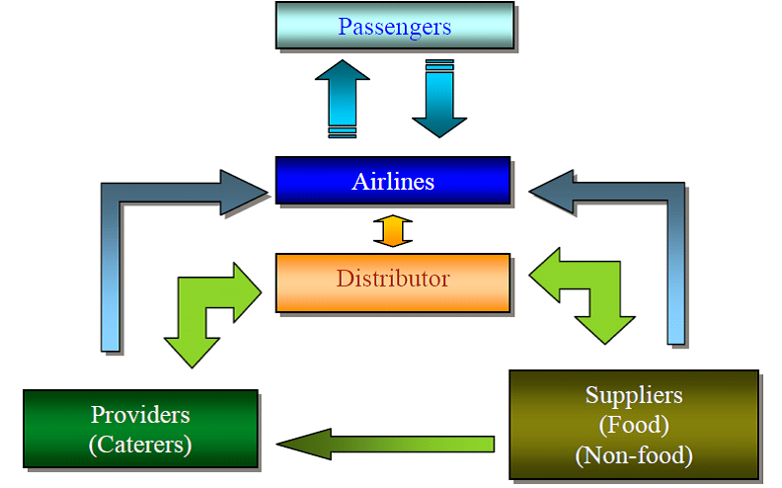

a) Role of the passenger
A feature of the airline industry is the huge diversity of customers. Prior to the 1960s, air travel was exclusive – only the very rich or government employees would fly longhaul. The development of jet aircraft and charter airlines lead to mass air travel. Subsequently in the 1990s, the business model was redesigned by the operators of so called low cost or budget airlines.

b) Role of airlines
Airlines are responsible for the design of onboard service. This is affected by the time of flight, length of flight, point of embarkation and disembarkation, nationality or ethnicity of passengers, seat class (economy, business or first), budget allowed by
the airline, price of food, seasonality of food, cost of labour to make a food item, time required to serve the food, number of flight attendants available to serve food, time needed to consume food, ability of meal to be consumed in a small place on a plane, the time and effort needed to clear an item, the needs and desires of the passengers, odours that may penetrate the cabin, the ability of meal to be rethermalised and the ability of the meal to withstand low humidity and pressures. Given this long list of variables it is not surprising that the nature of onboard service varies widely from flight to flight and airline to airline.

c) Role of caterers
Caterers have two main roles: to prepare items not bought in directly from suppliers
to a state ready for loading on board and to assemble trays and trolleys. Flight kitchens are always located near to major airports and are usually used to 'manufacture' consumable food items. There are two main reasons why menu items
may be made outside of airport-based flight kitchens: the cost of space and the cost
of labour. Airport space is at a premium so often it is not feasible for a flight kitchen to produce all of the meals needed for every seat class. For instance, some flight kitchens or caterers may make their first-class, and in some cases business-class,
meals from scratch at the flight kitchen and outsource all other meal production.
The caterer is often in an unusual and sometimes difficult, position. Although they are a customer of the supplier, the products used may not be of their choosing but may have been determined by the airline. When the products used are those purchased directly by the airline, caterers only charge for a handling and storage fee of the product but not the cost of the product. For instance, all liquor products for tax reasons must be purchased by the airlines, either through a prepaid arrangement with the distributor or through an arrangement whereby the charges are directly invoiced to the airline. However, the caterer is often responsible for keeping and accounting for any such products and these products are usually delivered directly to the caterer’s bonded store. The challenge for caterers is that the products are the property of the individual airlines served by the caterer. Products belonging to one airline cannot be used for another, even if the two airlines use identical products.

d) Role of suppliers
Suppliers may supply the inflight industry in two main ways. First, based on the planned menus, the supplier receives direct orders from the airlines, although they deliver their goods to flight kitchens operated by the contracted caterers. Airlines buy direct from suppliers because they want to have continuity of supply in all their stations, because they negotiate a discount, or because they want to maintain a particular brand image. Second, the supplier may supply the caterer directly, with
products that meet the contract specification.

Likewise suppliers have two approaches to manufacturing their products. Some supply airlines (or their caterers) with their standard products, whereas others make and supply specialist products specifically designed for the in-flight kitchen. In the first instance, the manufacture of these products is likely to take place in a factory or plant producing many other products. The products for in-flight service may be slightly modified for that market. For instance, spirits manufacturers need to bottle their spirits in miniatures rather than 40 oz bottles. In the second case, the manufacturer concentrates on simply producing a cycle of food items, often providing their sole business and hence they can produce large amounts of these items to be sold to the flight kitchen, as a method of outsourcing. These food manufacturers can make these items in volume at a lower cost than the flight kitchen can. The cost of labour to mass produce meals is obviously cheaper a good distance away from large cities where airports must exist. Historically it was mainly frozen meals, or ‘pop-outs’ as they are called in the USA, that were outsourced in this way. Today all kinds of specialist food items may be outsourced, such as canapes, ethnic meals, vegetarian items, patisserie, and so on.

e) Role of distributors
Distributors are typically global logistics companies, specialising in moving goods around the world, often in containers. They provide two main services for airlines or caterers. They can distribute materials and meals from vendor/suppliers to both the caterers and the airlines and they can track the numbers, volumes, and brands of the products they distribute. Using a specialised distributor or logistics company allows the airline and caterer to better manage the flow of materials from aircraft to

INFORMATION NEED FOR FLIGHT CATERING
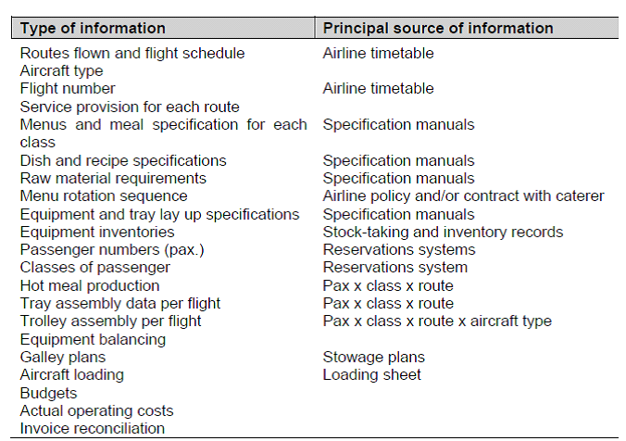

PRODUCTION SCHEDULE
As far as the airlines catering is concerned, hygiene is a very important factor. It must be understood that although catering is important, flying the aircraft is much more important than that as far as the Airlines companies are concerned. Food is just a part of the entire flying experience. Another important aspect of air catering is that it is not possible to delay the food in any way. The flight cannot be delayed on the grounds that food has not reached!!!!!!! Moreover, there is no opportunity of deviation from the pre – set weight, rotation and presentation of food.
These aspects make the airlines catering much more challenging……….It is important to be flawless and perfect as far as the production schedule is concerned. There is no margin for error.
Presently in air catering, THREE DAYS CYCLE IS FOLLOWED….i.e, Butchery and veg mise – en – place is done on day 1, the preparation and subsequent chilling is done on day 2, packing and departure of food on day 3. To maintain this, the ordering of raw materials is done 4 days in advance.
The production is done one shift in advance………….The exact scheduling can be done if the time calculations are done backwards.

WORK FLOW
The work of the Flight Catering can be broadly divided into two halves: The cooking of food and its packaging and loading……….The responsibility of the caterer ends after the food is handed over to the crew on board.
The Provisional load is placed 24 hours in advance. Exact figure can never be given as there are bound to be variations due to last minute reservations and cancellations. After the initial load is specified by an airliner, revised load, if any, is also provided after a specified time gap. Buy on Board (BOB) orders are revised three to four times as per the contract between the airlines and the caterer. A KOT is raised accordingly and the food is packed from the holding. The trays are also set up as per the requirements. (The tray set up is not the responsibility of the production section)
As per the trend of the consumption and the rotation to be served, the purchase ordering sheet is filled up. With the help of a proper software it reaches on line to the purchase manager. The ingredients are ordered for and duly checked at the receiving. Segregation of the stores are done. Bottled and tinned products, rice, cereals, oil etc are sent to the store room. The vegetables are washed and sent to the veg prep area. All the items needing frozen storage is sent to the appropriate deep freezer. Egg, cheese etc are sent to refrigerated storage. The kitchen can pick up the things as per the requirement from the store through on – line requisition. The receiving brings to the knowledge of the kitchen immediately any kind of short supply. The store maintains a par stock of approximately one week’s consumption.
The food is then processed keeping in view the production schedule. At every processing point, temperature control is kept. Ultimately after the food is prepared, except certain items, they are blast chilled and sent to the holding areas from where they are portioned out in the Dish out area as per the KOT received. Weight specifications and the presentation, if any must be strictly adhered to here. After portioning, the food is again sent to the holding area. These are loaded onto different trolleys. The operations take care of the food from here. There are different coloured tags which help in easy identification as to which material, be it raw of processed belongs to which day of the week.
The operations double check and then the airliner representative seals the trolleys. These are then loaded onto the hi loaders which take the food away to the aircraft.
In every area there are area SOPs which are to be followed and the area CCP to be strictly maintained.
- VOML(Veg Oriental Meal)
- GFL(Gluten Free Meal)
- MOML (Muslim Meal)
- HNML (Hindu Non veg Meal)
- AVML (Asian veg meal)
- Kosher Meal (Jewish – not served in Tajsats)
- VLML (Veg Lacto Meal)
ABBREVIATIONS OF SPECIAL MEALS ON OFFER
- Jain meal
- Vegan meal (non dairy veg)
- Child meal (non spicy)
- LCML (Low Calorie Meal)
- DTML (Diet Meal)
- DBML (Diabetic Meal)
- LPML (Low Purine Meal)
- LSML (Low Salt Meal)
TRAY SET UP INTRICACIES
The tray set – up depends mainly on the course of meal and the items offered are general ones irrespective of the rotation followed except in some cases….. An example of tray set up configuration:
BREAKFAST:
- Cut fruits
- Bread rolls
- Yoghurt (in case of north Indian breakfast option)
- Coconut chutney (in case of South Indian breakfast)
- Tomato chutney (in case of South Indian breakfast)
- Jam and Butter sachet
There can be significance difference in the economy class and business class set – up.
SNACKS:
- Mint chutney
- Cut fruits or desserts
LUNCH / DINNER:
- Salad (as per the rotation)
- Dessert (as per the rotation)
TRAY AND CART DETAILS:
Normally there are three types of trays, although every caterer has its own standards.
- Full tray (for lunch / dinner)
- Quarter tray (snacks)
- Half tray (These are used for several courses and are carried in flights doing more than one sector)
There are two types of carts, normally used with variations:
- Half carts: This can hold 14 full trays, 28 quarter trays and 14 half trays
- Full carts: This can hold 28 full trays, 56 quarter trays and 42 half trays.
These carts are put in the holding after being loaded as per the tag attached to it. These are checked, sealed and loaded on to the high loader.
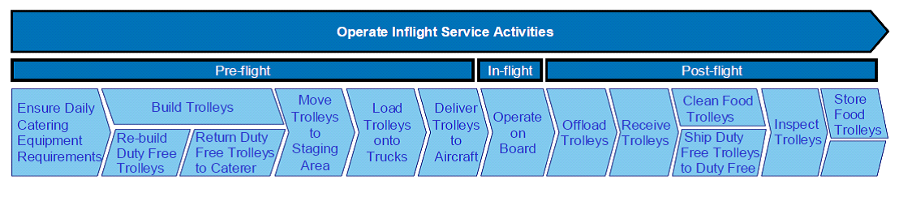
TROLLEY CONTROL FLOW CHART

OVEN CARTS: There are 8 racks. Each rack can hold 4 meals (300ml foil box) OR 2 medium foil meals (500ml foil box) i.e, depending on the capacity it can hold 32 meals or 16 meals.
FOOD HANDLING ON AIRCRAFT
Food storage and preparation for serving takes place in aircraft galleys, which mostly have very limited space and equipment for this purpose. In common with any kitchen, a galley has to provide the following: cold storage areas, regeneration ovens, water boilers and beverage machines and the stowage of waste products. On narrow-bodied aircraft, the meals are kept chilled by using dry ice located within the trolley. Wide-body aircraft used for long-haul flights are today usually equipped with refrigerators or chiller units for trolleys.
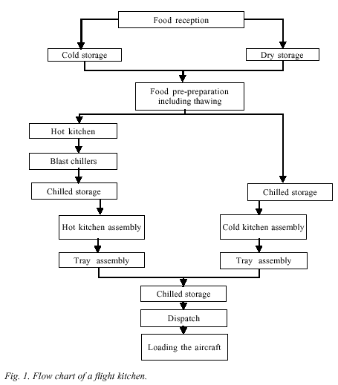

HYGIENE CONTROL IN FLIGHT CATERING
While choosing menus for airlines, certain foods that can constitute a health hazard should be avoided as an important preventive measure. Components of aircraft meals can be placed into four risk categories: dangerous, high-risk, medium- and low-risk items. Products that by nature can constitute a risk as a ready meal, either as such or due to improper heat treatment on board, are classified as dangerous items. These items include dairy products containing raw milk, undercooked poultry and raw or undercooked eggs, raw meat, raw shellfish and raw fish. Neither should raw sprouts be used as components of cold meals due to known Salmonella outbreaks.
Products which are intensively handled after heat treatment are classified as high-risk items. Such products include poultry and meat de-boned after cooking, stuffed eggs, cold cuts, glazing, cooked shellfish peeled after heat treatment. Medium-risk items have undergone a minimum of handling after heat treatment and include fermented and air-dried meats and sausages, stews, rice and pastas. Acidified foods, fresh fruits that can be peeled prior to eating, canned fruits, bread and dry bakery items are considered to be low-risk items.
Food handlers are a potential source of pathogenic micro-organisms, and therefore training and practice for good personal hygiene is needed. Food handlers should have a medical examination prior to employment, and should be kept under regular medical surveillance. A person known or suspected to be suffering from a disease likely to be transmitted through food or any person afflicted with infected wounds, skin infections or sores should not be allowed to work in contact with any unpacked foods. In order to ensure that food suppliers have implemented and maintain a sufficient control level in their production plant, flight caterers should audit their suppliers.
Official control : The official control of flight kitchens depends on the national legislation of the country where the premises are located. A strict compliance to HACCP aspects are essential and the Standard Operating Procedures must be as per the HACCP guidelines. There must be audits from time to time to ensure that there is no deviation from the standards.
ISSUES AND TRENDS
All commercial activity is subject to external forces. These forces inevitably cause an industry to change and adapt over time. Typically, companies scan the environment in order to identify factors that may affect them in the future in order to develop new policies and new products and services. Such scanning is usually organised under five main headings:
• Political forces
• Economic factors
• Social trends
• Technological change
• Environmental concerns
In reality, many external events span more than one of these categories. For instance, the creation of a single currency (the ‘euro’) in Europe is predominantly an economic issue, but it also has political and possibly social effects too. The flight catering industry is no exception to this. There are probably five main issues that will significantly affect the whole industry.

- The first key issue is industry structure. Until the 1990s, the industry was highly fragmented with many small companies, often with only a national or regional presence. During the last fifteen years, the industry has seen significant concentration and the emergence of two very large global companies. Linked to this has been an increase in airlines contracting out their catering provision rather than operating their own facilities.

- The second key issue is competition. The growth of large firms in the industry has significantly increased competition in the industry. This has occurred at a time when airlines are increasingly competitive, especially with the major growth of low cost carriers. This has led to a significant pressure on costs and has implications for the profit margins of flight catering companies. This challenge has only increased due to other pressures.

- The third issue is security. Throughout most of the second half of the twentieth century, the world order was based around the so-called ‘cold war’ between the western world and the Soviet bloc. With the break up of the Soviet bloc, the world order has changed significantly with a major shift towards terrorism based on religious fundamentalism. The use of aircraft in the attack on the New York World Trade Center on 11 September 2001 has led to security becoming a major issue.

- The fourth issue is outsourcing. Pressure on costs and increased competition has led flight catering companies to re-think their business model. They are thinking of themselves less as caterers and more as experts in logistics. Much of the production activity in kitchens is being outsourced to food manufacturers and suppliers.

- The final issue is information technology and, in particular, the Internet. The development of this has enabled firms to redesign their processes and to manage through outsourcing. It also provides better management information, thereby helping to monitor costs more effectively.

FUTURE TRENDS
As airlines continue to demand higher quality inflight food offerings at lower prices,
in flight caterers and suppliers are continually exploring new, innovative and diverse
ways of remaining competitive.

a) More diversity of onboard offer:
Airlines throughout the world are experimenting with different ways of serving meals to passengers. These options include buy-on-board food products, buy-at-the gate options, giveaway-at-the-gate and offering a picnic bag rather than tray-set.

b) More blurring of stakeholders in the supply chain:
Suppliers have begun to eliminate some elements of the supply chain so that they can supply airlines from wherever their factories are located. This is often in direct competition with airline caterers and typically involves using disposable packaging
that eliminates the need for tray assembly and even trolley assembly.

c) Process Improvement in Flight Kitchens:
With the external pressures from customers and competitors, it is not surprising that all flight catering firms are seeking to reduce their costs by operating more efficiently.

To do this they have turned to the lessons learned in manufacturing and assembly
plants – most especially the concepts of lean or agile manufacturing and just-in-time production. The approach being adopted varies from firm to firm, and from plant to plant, but some clear trends are evident.

These are:
• Average cycle time (i.e, total processing time) in the industry used to be about 24 hours – some plants have reduced this to 8 hours
• Reducing cycle time has been achieved by taking ‘waste’ out of the system – wasted time, wasted movement, too much stock, unnecessary transportation, etc.
• An industry norm was that each aircraft need 3.5 sets of equipment (one set on the plane, one being cleaned at the point of departure, one ready for loading at the point of arrival, and a half set to cover losses and breakages). By reducing cycle time, global caterers have significantly reduced the total amount of equipment in the system
• Less equipment frees up space in plants to enable revision to process layouts, simplify inventory control, and generally use space more efficiently
• Inventory management is switching to the kanban system, i.e, standardised bins of each inventory item.
• Non-standard catering, such as for special meals, is being outsourced to specialist suppliers

********************************************************

